Annabella 2011 Pinot Noir
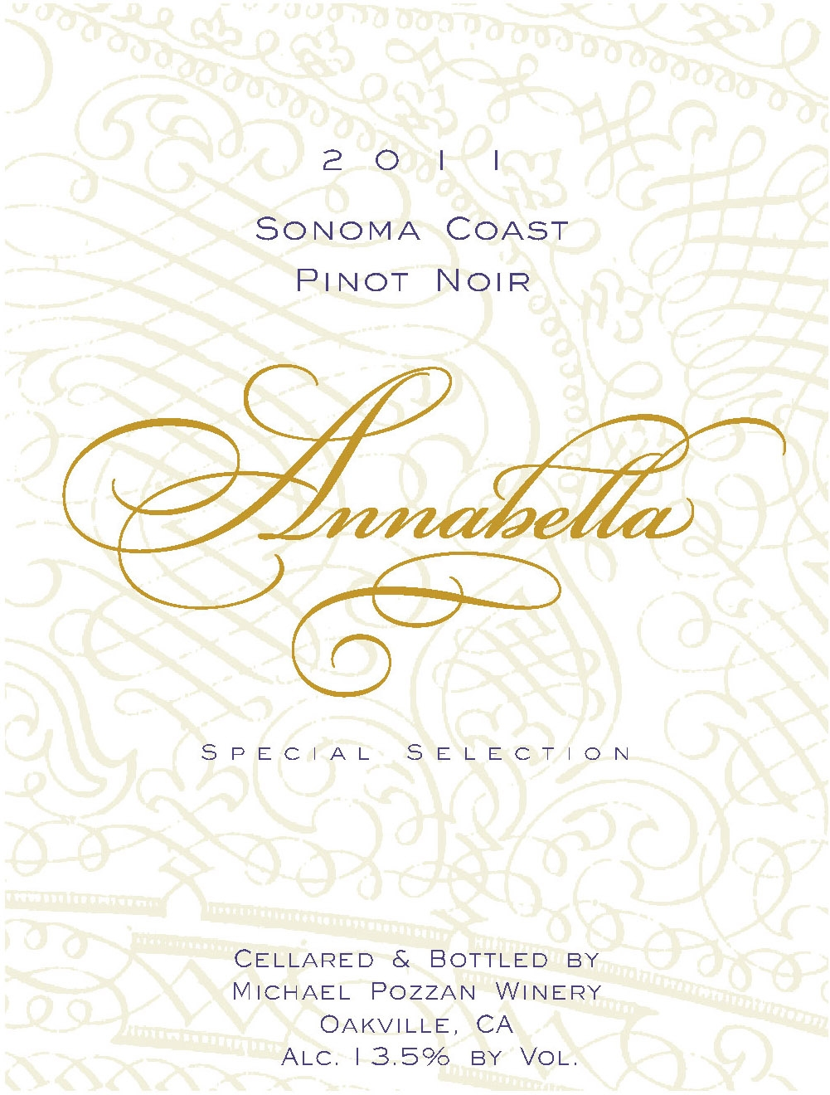

100% Pinot Noir
100% Sonoma Coast
Aged 11 months in French oak
Smokey, dried cherry fruit in the nose with a vibrant bust of blueberry flavors in the finish. Aromatically, the wine has sweet and sour cherry flavors, along with clove and cinnamon. The subtle oak overtones, makes this a perfect wine to pair with roasted garlic chicken, rigatoni tossed with an Abruzzi style lamb ragu, or an aged Camembert cheese. Medium tannins allow this wine to drink well now, but will improve over the next three years.

